Watershed Outlet Monitoring Program

Eagle Creek Station

Savage, MN

Quarterly Report

Preliminary Data

April - June 2007

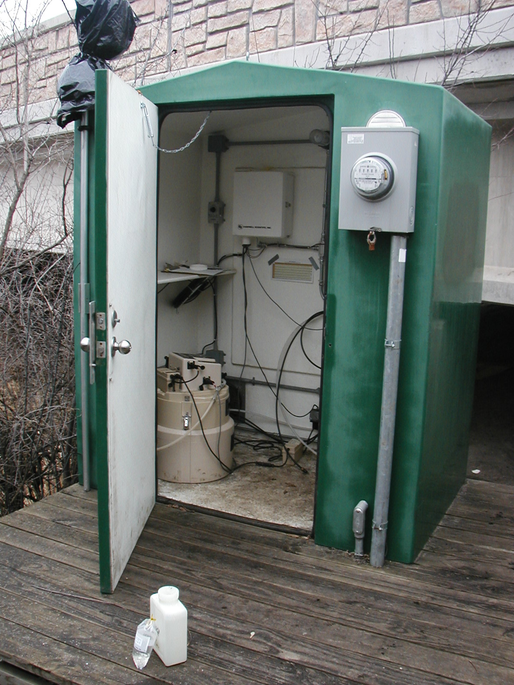

Prepared By:
Jaime Rockney
Water Quality Technician
Scott Soil and Water Conservation District

Prepared For:

Lower Minnesota River Watershed District

August 2007
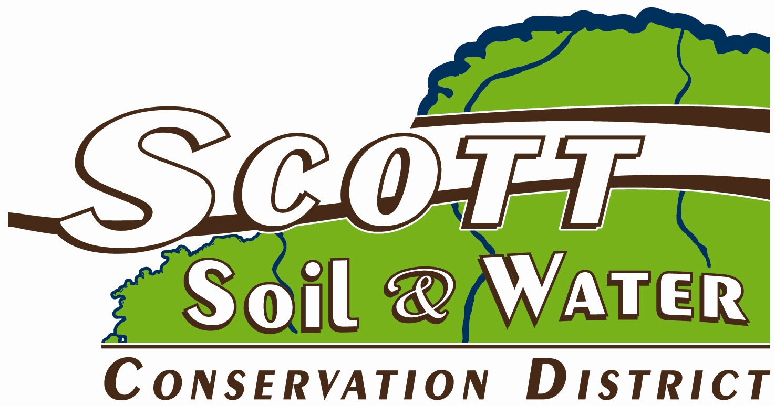

Introduction

The Eagle Creek WOMP site, located in Savage near Hwy. 13 and Hwy 101. This report summarizes the results of flow, precipitation, and water quality for the 2nd quarter of 2007. This data is preliminary and is subject to change until the Metropolitan Council submits the final report for this period.

Flow and Precipitation

Table 1. Average flow and total precipitation at Eagle Creek WOMP Station April - June 2007

Period | Average Flow (cfs) | *Precipitation (inches) | 30 year precipitation average from state climatology office
April | 7.97 | 2.01 | 2.13
May | 7.78 | 2.40 | 3.68
June | 7.71 | 1.56 | 4.76
TOTAL QUARTER | 7.82 | 5.97 | 10.57
*Precipitation data obtained from volunteer rain gauge monitor in Shakopee

Figure 1. Flow and precipitation at Eagle Creek WOMP Station, April - June 2007. Beaver dam removed upstream on June 26 to cause spike in flow.

Water Quality
Three low flow grab samples were collected at the Eagle Creek WOMP Station during the 2nd quarter in 2007. There were no significant rain events so no composites were taken. Overall, water quality was excellent with all parameters in compliance with state standards or near the ecoregion mean (Table 2). The results of 2nd quarter seem to support the idea that ducks were influencing the water quality results of 1st quarter; Fecal Coliform, Solids, Nitrate/Nitrite’s, and Turbidity are all lower this quarter.

Table 2. Average concentrations at Eagle Creek WOMP Station
Parameter | 1st quarter Ave. Concentration | 2nd Quarter Ave Concentration | Unit | Notes – 2nd Quarter Results
Alkalinity | 253 | 259 | mg/L | No state standard. 20 – 200 mg/L typical. Less than 10 mg/L indicate poor buffer.
Biological Oxygen Demand (BOD5) | 1.05 | 1.0 | mg/L | Ecoregion mean = 2.7 mg/L.
Cadmium | .04 | .04 | ug/L | State standard = 2.0 ug/L.
Chloride | 23.2 | 25.5 | mg/L | State standard = 230 mg/L.
Chlorophyll-a | 83.5 | 67.3 | ug/L
Chromium | .4 | .2 | ug/L | State standard = 365 ug/L.
COD | 13.8 | 8.7 | mg/L
Conductivity | 569 | 588 | mMHOs
Copper | .5 | .5 | ug/L | State standard = 15 ug/L.
Dissolved Oxygen | 8.89 | 8.3 | mg/L | State standared = 7 mg/L.
Fecal Coliform Bacteria | 102 | 43.7 | CFU/100mL | State standard = 200 CFU/100 ml water as geomean of at least 5 samples per month Apr – Oct.
Hardness | 286 | 291 | mg/L | No state standard. Water above 180 mg/L considered very hard water.
Lead | .3 | .1 | ug/L | State standard = 7.7 ug/L.
Nickel | 3 | 2.7 | ug/L | State standard = 283 ug/L.
Nitrogen Ammonia | .05 | .05 | mg/L | State standard = .016 mg/L.
Nitrate + Nitrite | .32 | .12 | mg/L | Ecoregion mean = .16 mg/L.
pH | 7.75 | 7.61 | su | State standard = not less than 6.5 nor greater than 8.5.
Phosphorus, Total | .08 | .04 | mg/L | Ecoregion mean = 0.13 mg/L. EPA recommends less than 0.1 mg/L. These results are the unfiltered average of result.
Suspended Solids | 11 | 4 | mg/L | Ecoregion mean = 13.7.
Total Kjeldahl Nitrogen | .34 | .32 | mg/L
Total Organic Carbon | 2.84 | 2.8 | mg/L
Turbidity | 10.11 | 4.02 | NTU | State standard = 10 NTU
Volatile Suspended Solids | 3.4 | 1.6 | mg/L
Zinc | .9 | 3.0 | ug/L | State standard = 191 ug/L
mg/L = milligrams per liter ug/L = micrograms per liter
mMHO = micromhos or micorseimens CFU = colony forming units
NTU = nephelometric turbidity units Highlighted areas indicate areas of concern.
su = standard units
State standard = state standard for Class 2A waters with a hardness greater than 200
Appendix A - Watershed and land use information provided by Metropolitan Council Environmental Services.

