Watershed Outlet Monitoring Program

Eagle Creek Station

Savage, MN

Quarterly Report

Preliminary Data

January – March 2007

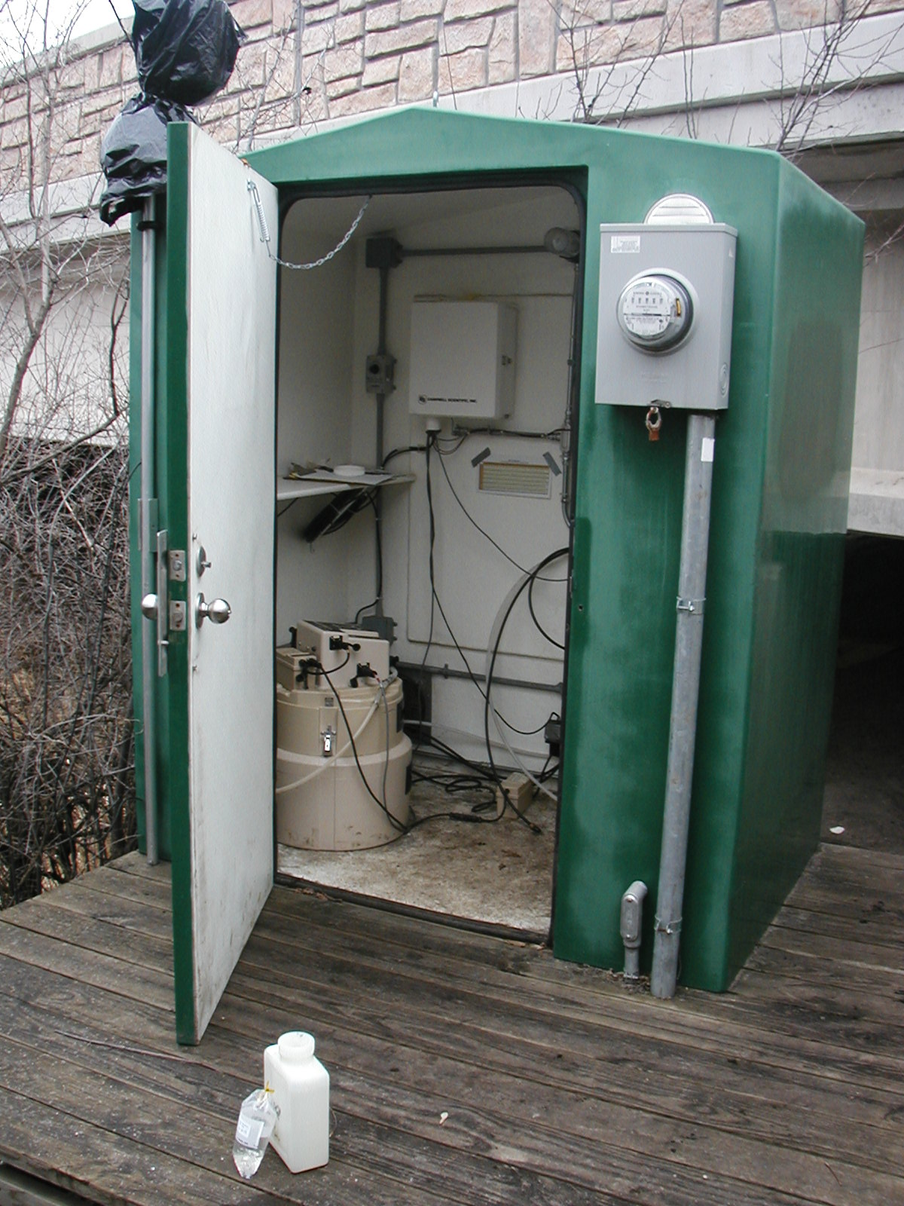

Prepared By:
Jaime Rockney
Water Quality Technician
Scott Soil and Water Conservation District

Prepared For:

Lower Minnesota River Watershed District

July 2007
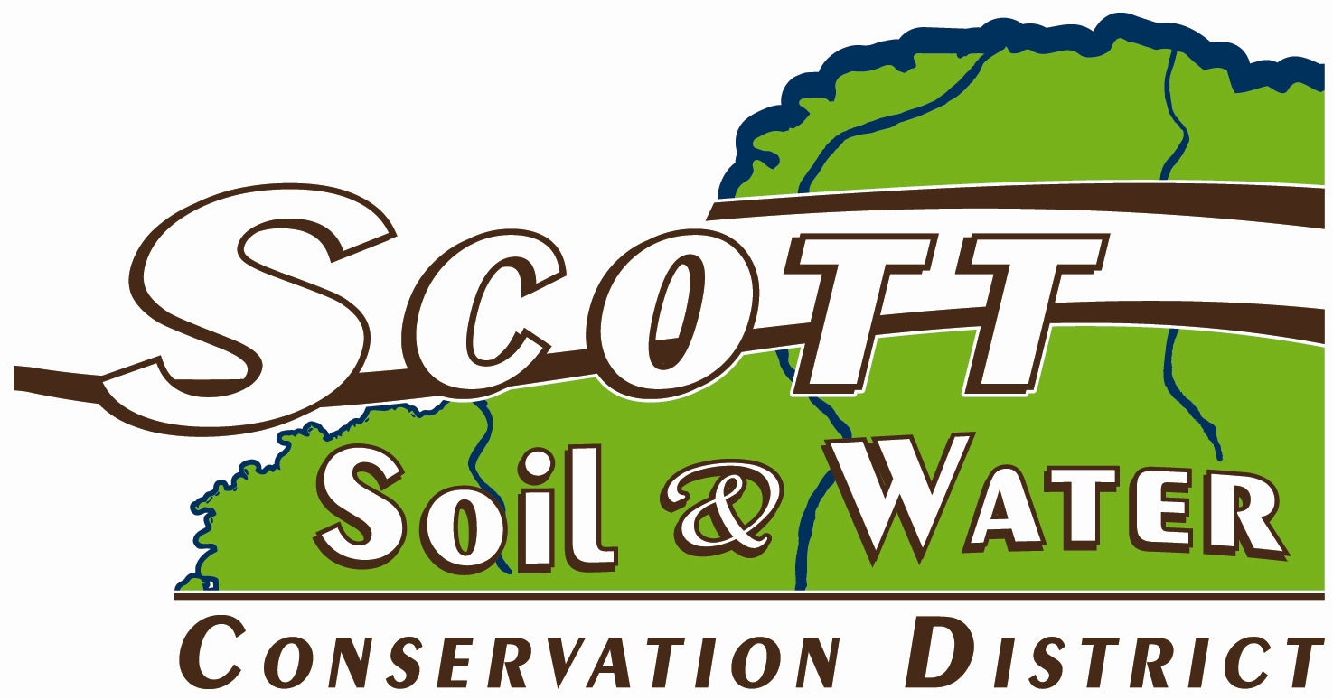

Introduction

The Eagle Creek WOMP site, located in Savage near Hwy. 13 and Hwy 101. This report summarizes the results of flow, precipitation, and water quality for the 1st quarter of 2007. This data is preliminary and is subject to change until the Metropolitan Council submits the final report for this period.

Flow and Precipitation

Table 1. Average flow and total precipitation at Eagle Creek WOMP Station January – March 2007

Period | Average Flow (cfs) | *Precipitation (inches) | Average precipitation for Shakopee obtained from weather.com
JANUARY | 8.18 | .35 | .93
FEBRUARY | 7.56 | 1.20 | .62
MARCH | 9.17 | 4.11 | 1.77
TOTAL QUARTER | 8.30 | 5.66 | 3.32
*Precipitation data obtained from volunteer rain gauge monitor in Shakopee

Figure 1. Flow and precipitation at Eagle Creek WOMP Station January – March 2007. The rain gauge was uncovered on March 13.

Water Quality

One event composite sample, one event grab, and three low flow grab samples were collected at the Eagle Creek WOMP Station during the 1st quarter 2007. Overall, water quality was good with nearly all parameters in compliance with state standards or near the ecoregion mean (Table 2). From observations in the past, as well as this year, ducks have congregated on Eagle Creek during the winter months because of the lack of ice. This has caused some elevated water quality results.

Table 2. Average concentrations at Eagle Creek WOMP Station
Parameter | 1st quarter 2007  Ave. Concentration | Unit | Notes – 1st quarter results
Alkalinity | 253 | mg/L | No state standard. 20 – 200 mg/L typical. Less than 10 mg/L indicate poor buffer.
Biological Oxygen Demand (BOD5) | 1.05 | mg/L | Ecoregion mean = 2.7 mg/L.
Cadmium | .04 | ug/L | State standard = 2.0 ug/L.
Chloride | 23.2 | mg/L | State standard = 230 mg/L.
Chlorophyll-a | 83.5 | ug/L
Chromium | .4 | ug/L | State standard = 365 ug/L.
COD | 13.8 | mg/L
Conductivity | 569 | mMHOs
Copper | .5 | ug/L | State standard = 15 ug/L.
Dissolved Oxygen | 8.89 | mg/L | State standared = 7 mg/L.
Fecal Coliform Bacteria | 102 | CFU/100mL | State standard = 200 CFU/100 ml water as geomean of at least 5 samples per month Apr – Oct. Samples were much higher in January and February.
Hardness | 286 | mg/L | No state standard. Water above 180 mg/L considered very hard water.
Lead | .3 | ug/L | State standard = 7.7 ug/L.
Nickel | 3 | ug/L | State standard = 283 ug/L.
Nitrogen Ammonia | .05 | ug/L | State standard = 16 ug/L.
Nitrate + Nitrite | .32 | mg/L | Ecoregion mean = .16 mg/L. Could be elevated due to large number of ducks in stream.
pH | 7.75 | su | State standard = not less than 6.5 nor greater than 8.5.
Phosphorus, Total | .01 | mg/L | Ecoregion mean = .13 mg/L. EPA recommends less than 0.1 mg/L.
Suspended Solids | 11 | mg/L | Ecoregion mean = 13.7. Eagle is usually lower in the non-winter months. Again, it is most likely due to the ducks.
TKN (Total Kjeldahl Nitrogen | .34 | mg/L
Total Organic Carbon | 2.84 | mg/L
Turbidity | 10.11 | NTU | State standard = 10 NTU Could be elevated due to large number of ducks in stream.
Volatile Suspended Solids | 3.4 | mg/L
Zinc | .9 | ug/L | State standard = 191 ug/L
mg/L = milligrams per liter or parts per million (ppm)
ug/L = micrograms per liter or parts per billion (ppb)
mMHO = micromhos or micorseimens
CFU = colony forming units
NTU = nephelometric turbidity units
State standard = state standard for Class 2A waters with a hardness greater than 200
Appendix A - Watershed and land use information provided by Metropolitan Council Environmental Services.

